**EYFS Suggested List of Authors**

There is a wealth of children’s stories available with new and innovative authors constantly coming to the fore. Below, we have listed one of a few authors’ better-known books, but many of them are very prolific writers and have written many stories that you can enjoy with your children.

Please, with the wealth of new literature available, do not forget about traditional fairy tales and nursery rhymes which offer rich language and often introduce the children to rhyme.

Young children are also fascinated by the natural world and thoroughly enjoy non-fiction books, particularly those with colourful images. These can form the basis for extended conversations, to broaden their vocabulary and general knowledge.

If you discover a new family favourite, please do send it in with your child to share with their class!

Ahlberg (Janet and Allan) – Jolly Postman

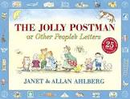

Butterworth (Nick) – Percy the Park Keeper

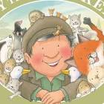

Browne (Anthony) – My Mum

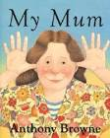

Carle (Eric) – Hungry Caterpillar

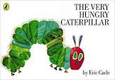

Chamberlain (Mary and Rich) – Mama Panya’s Pancakes

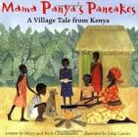

Cole (Babette) – The Trouble with Mum

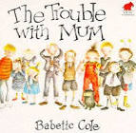

Dodd (Lynley) – Hairy McClary , Slinky Malinky

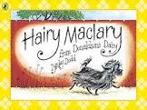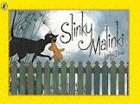

Dr Seuss – Cat in the Hat

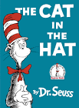

Donaldson (Julia) – The Gruffalo

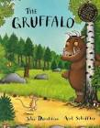

Faulkner – The Wide Mouthed Frog

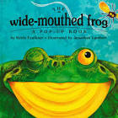

Foster (John) – Rhymes for the very young

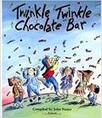

Freedman (Claire) & Cort (Ben) – Aliens love underpants

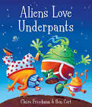

Hedderwick (Mairi) – Katie Morag stories

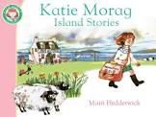

Horacek (Petr) – Blue Penguin

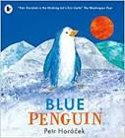

Hughes (Shirley) – Lucy and Tom stories

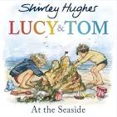

Hutchins (Pat) – Rosie’s Walk

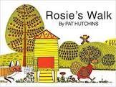

[Chapatti Moon](https://www.penguin.co.uk/books/1098046/chapatti-moon.html) by [Pippa Goodhart](https://www.penguin.co.uk/authors/131032/pippa-goodhart.html)

[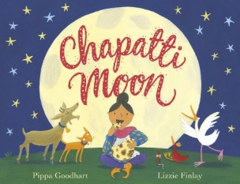](https://www.penguin.co.uk/books/1098046/chapatti-moon/9781848531284.html)

Inkpen (Mick) – Nothing

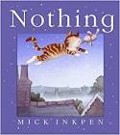

Kerr (Judith) – Mog the cat stories

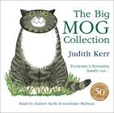

Maddox – Fergus stories

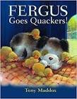

McNaughton (Colin) – Oops!

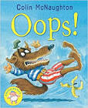

Moore – Six Dinners Sid

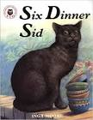

Murphy (Jill) – Peace at Last

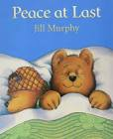

Pfister (Marcus) – Rainbow Fish

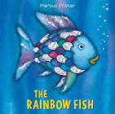

Rosen (Michael) – A Greta Big Cuddle – Poems for the Very Young

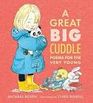

Rosen (Michael) – Going on a Bear Hunt

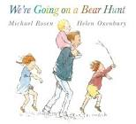

[Last Stop on Market Street](https://www.penguin.co.uk/books/300124/last-stop-on-market-street.html) by [Matt de la Peña](https://www.penguin.co.uk/authors/128968/matt-de-la-pena.html)

[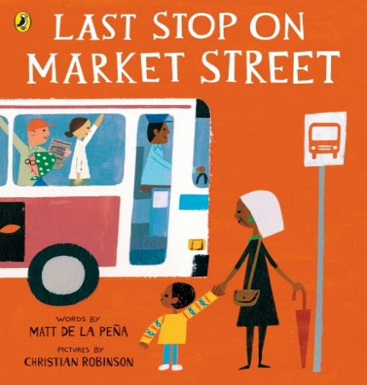](https://www.penguin.co.uk/books/300124/last-stop-on-market-street/9780141374185.html)

Sharratt (Nick) – Elephant Wellyphant

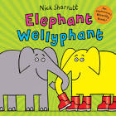

Tobia (Ainuke and Lauren) – Anna Hibiscus

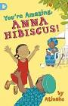

Mommy’s Khimar by Jamilah Thompkins-Bigelow

[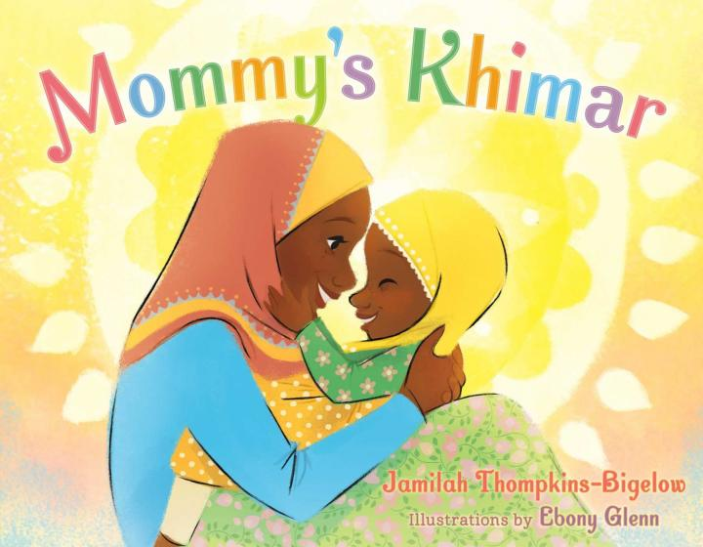](https://www.amazon.co.uk/Mommys-Khimar-Jamilah-Thompkins-Bigelow/dp/1534400591/ref=nosim?tag=myc0e-21)